Growing Schools Marketplace
14 July 2016
Application Form
Please read the form carefully, complete and email to julie@sustainweb.org by Monday 4th July 2016

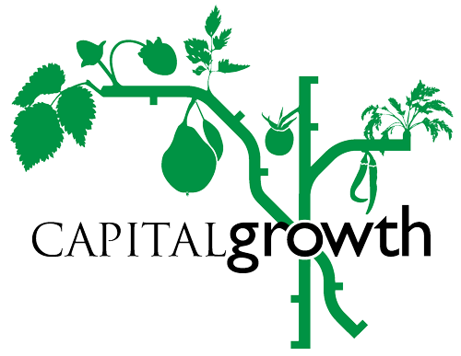

London’s food growing network
c/o Sustain: the alliance for
better food and farming
Development House
56 - 64 Leonard Street, London EC2A 4LT
Registered charity no: 0108643

Contact Details

Your name:
Name of the school
Capital Growth space number
(if applicable)
Email:
Phone number:

What produce/products do you think you will bring to the school marketplace and in which quantities? We would like to see anything from fresh produce to school made goods like jam, chutney, cordial, potted plants, seeds, home-grown fresh vegetables and fruits. Everything should include produce from your school garden.

We allow a maximum of 5 people to come to the marketplace including adults and children (you need to be able to bring pupils along). How many people would you like to bring along? Please specify the number of children and adults

Will your school be able to enter our ‘Showcase your growing’ competition? The competition requires schools to create an A2 display of pictures, recipes and stories about their garden. We will send you more details once we receive your application. The competition will be judged at the Marketplace.

Please note
- Each school will be allocated ONE TABLE (1 meter by 2 meters) so only bring enough produce for one table and make sure you can carry what you bring
- Parking at City Hall is difficult so we ask that unless you need a disabled parking space you use public transport. If you need a disabled parking space please let us know by emailing julie@sustainweb.org .

Thank you for taking part and if you have any questions please email julie@sustainweb.org

